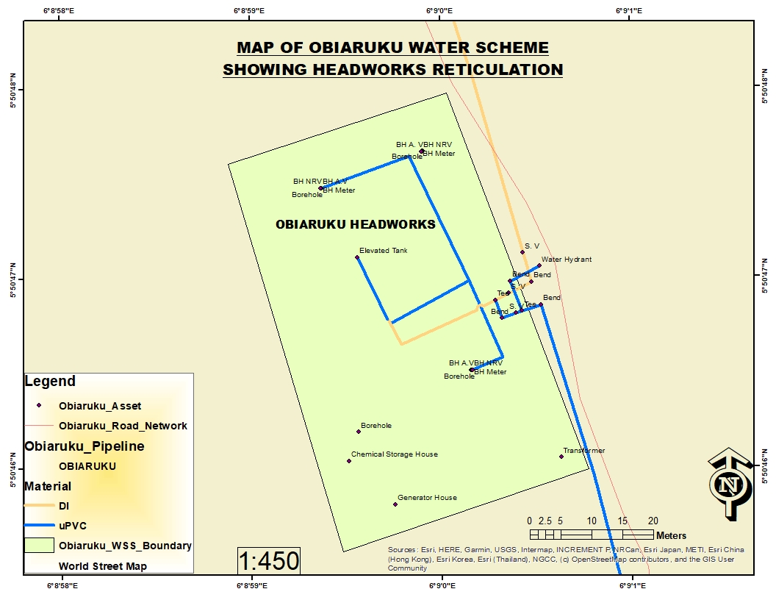

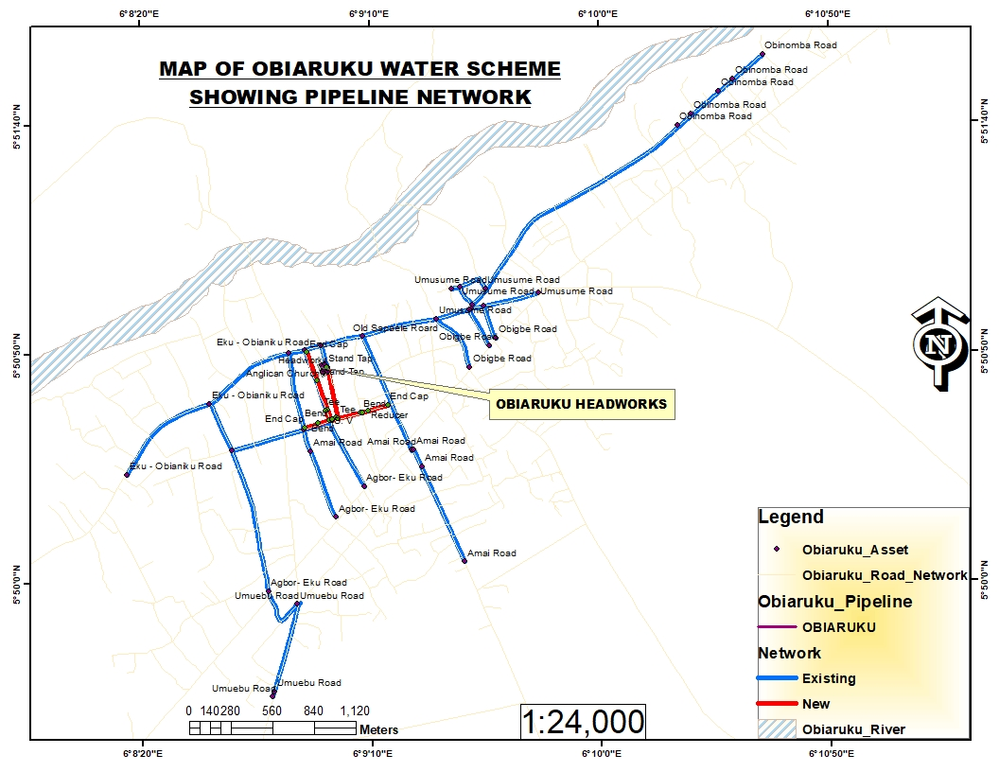

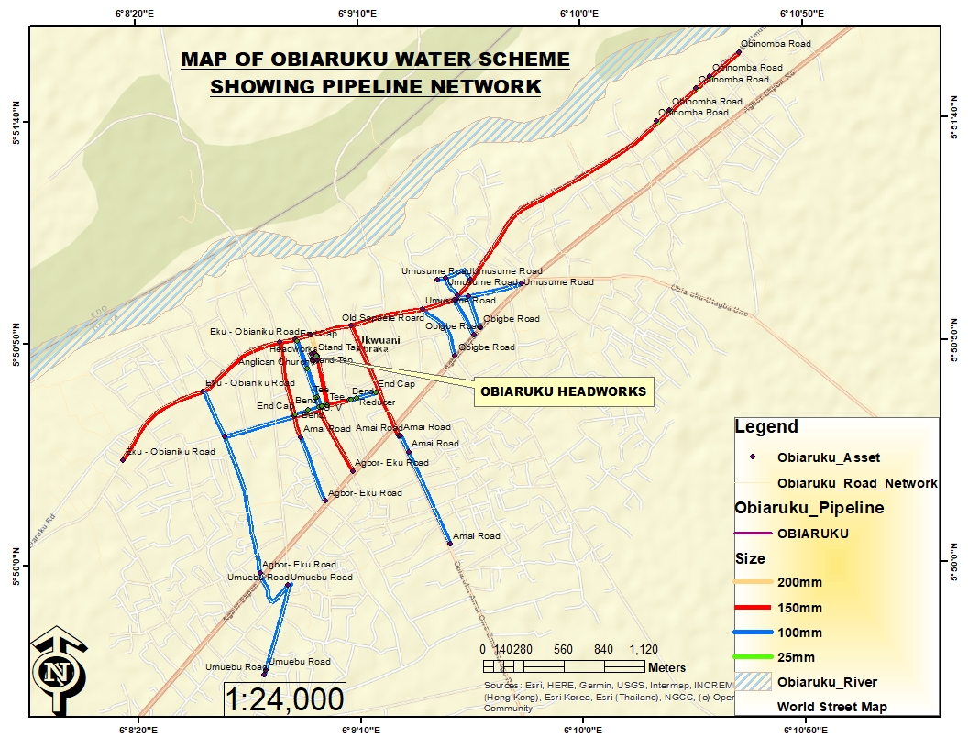

**PICTURES FROM THE FIELD - OBIARUKU WATER SUPPLY SCHEME**

|  |  |  |  |  |  |  |  |  |  |  |
| --- | --- | --- | --- | --- | --- | --- | --- | --- | --- | --- |
| |  |  | | --- | --- | | Arrival of Gen. Set at Obiaruku Headworks | Pulling/installation of submersible pump at Ika WSS | | Welding/jointing of HDPE pipes | Welding/jointing of HDPE pipes | | Inspection of submersible pump by Technical Team | Development of Borehole at Obiaruku Headworks | | Already laid HDPE pipeline | Pipeline laid at Umudike Street | | Newly laid interlocking tiles at Obiaruku Headworks | Entrance Gate at Obiaruku Headworks | |

**OBIARUKU WATER SUPPLY SCHEME – FIELD ASSETS CAPTURED**

|  |  |  |  |  |  |  |  |  |  |  |  |  |
| --- | --- | --- | --- | --- | --- | --- | --- | --- | --- | --- | --- | --- |
| **S/NO** | **LOCATION** | **ASSET TYPE** | **SIZE** | **PIPE MATERIAL** | **CONDITION** | **PAVEMENT TYPE** | **CHAMBER Y/N** | **MARK POST Y/N** | **MARK PLATE** | **METER NO** | **LONGITUDE** | **LATITUDE** |
| 1 | Water Board by Aglican Church | Bend | 200mm | AC | Good | Earth | No | No | No | None | 184385 | 647026 |
| 2 | Water Board by Aglican Church | Standtap | 25mm | Steel | Good | Concrete | No | No | No | None | 184372 | 647025 |
| 3 | Water Board by Aglican Church | Sluice Valve | 200mm | Steel | Good | Concrete | Yes | No | No | None | 184378 | 647043 |
| 4 | Old Sapaele Roard | Tee | 150mm | Steel | Good | Concrete | No | No | No | None | 184340 | 647173 |
| 5 | Old Sapaele Roard | Tee | 150mm | Steel | Good | Earth | No | No | No | None | 184616 | 647231 |
| 6 | Amai Road | Sluice Valve | 150mm | Steel | Good | Earth | Yes | No | No | None | 184941 | 646466 |
| 7 | Amai Road | Reducer | 150mm*100mm | Upvc | Good | Concrete | No | No | No | None | 184260 | 646463 |
| 8 | Amai Road | Air Valve | 25mm | Upvc | Good | Earth | No | No | No | None | 185006 | 646353 |
| 9 | Amai Road | Endcap | 100mm | Upvc | Good | Earth | No | No | No | None | 185289 | 645713 |
| 10 | Amai Road | Bend | 100mm | Upvc | Good | Earth | No | No | No | None | 184955 | 646469 |
| 11 | Obigbe Road | Endcap | 100mm | Concrete | Good | Earth | No | No | No | None | 185336 | 647018 |
| 12 | Obinomba Road | Endcap | 150mm | Concrete | Good | Earth | No | No | No | None | 187322 | 649096 |
| 13 | Obinomba Road | Standtap | 25mm | Upvc | Bad | Concrete | No | No | No | None | 186745 | 648627 |
| 14 | Obinomba Road | Standtap | 25mm | Upvc | Bad | Concrete | No | No | No | None | 186840 | 648703 |
| 15 | Obinomba Road | Standtap | 25mm | Upvc | Bad | Concrete | No | No | No | None | 187026 | 648852 |
| 16 | Obinomba Road | Standtap | 25mm | Upvc | Bad | Concrete | No | No | No | None | 187119 | 648932 |
| 17 | Umusume Road | Tee | 150mm*100mm | Upvc | Good | Earth | No | No | No | None | 185355 | 647433 |
| 18 | Umusume Road | Tee | 100mm | Upvc | Good | Earth | No | No | No | None | 185431 | 647426 |
| 19 | Umusume Road | Endcap | 100mm | Upvc | Good | Earth | No | No | No | None | 185799 | 647514 |
| 20 | Umusume Road | Tee | 150mm*100mm | Upvc | Good | Earth | No | No | No | None | 185348 | 647410 |
| 21 | Umusume Road | Tee | 150mm*100mm | Upvc | Good | Earth | No | No | No | None | 185335 | 647406 |
| 22 | Umusume Road | Tee | 150mm*100mm | Upvc | Good | Earth | No | No | No | None | 185117 | 647344 |
| 23 | Umusume Road | Tee | 100mm*100mm | Upvc | Good | Earth | No | No | No | None | 185274 | 647559 |
| 24 | Umusume Road | Endcap | 100mm | Upvc | Good | Earth | No | No | No | None | 185221 | 647546 |
| 25 | Umusume Road | Endcap | 100mm | Upvc | Good | Earth | No | No | No | None | 185444 | 647542 |
| 26 | Obigbe Road | Endcap | 100mm | Concrete | Good | Earth | No | No | No | None | 185468 | 647163 |
| 27 | Obigbe Road | Endcap | 100mm | Concrete | Good | Earth | No | No | No | None | 185510 | 647210 |
| 28 | Headworks | Elevated Tank | 675m3 | Concrete | Good | Concrete | No | No | No | None | 184351 | 647028 |
| 29 | Headworks | Borehole | 200mm | Earth | Good | Concrete | No | No | No | None | 184345 | 647039 |
| 30 | Headworks | Borehole | 200mm | Earth | Good | Concrete | No | No | No | None | 184369 | 647009 |
| 31 | Headworks | Borehole | 200mm | Earth | Bad | Concrete | No | No | No | None | 184362 | 647045 |
| 32 | Headworks | Borehole | 200mm | Earth | Bad | Concrete | No | No | No | None | 184348 | 646999 |
| 33 | Umuebu Road | Endcap | 100mm | upvc | Good | Earth | No | No | No | None | 183990 | 644819 |
| 34 | Umuebu Road | Air Valve | 25mm | Cast Iron | Good | Earth | No | No | No | None | 184001 | 644855 |
| 35 | Umuebu Road | Tee | 100mm*100mm | upvc | Good | Earth | No | No | No | None | 184161 | 645439 |
| 36 | Umuebu Road | Sluice Valve | 100mm*100mm | Cast Iron | Good | Earth | No | No | No | None | 184161 | 645440 |
| 37 | Agbor- Eku Road | Sluice Valve | 100mm*100mm | Cast Iron | Good | Earth | No | No | No | None | 183971 | 645527 |
| 38 |  | Tee | 100mm*100mm | upvc | Good | Earth | No | No | No | None | 183734 | 646471 |
| 39 | Eku - Obianiku Road | Tee | 150mm*100mm | upvc | Good | Earth | No | No | No | None | 183588 | 646789 |
| 40 | Eku - Obianiku Road | Endcap | 150mm | AC | Good | Earth | No | No | No | None | 183028 | 646318 |
| 41 | Eku - Obianiku Road | Tee | 150mm*100mm | upvc | Good | Earth | No | No | No | None | 184125 | 647121 |
| 42 |  | Tee | 150mm*100mm | upvc | Good | Earth | No | No | No | None | 184218 | 646608 |
| 43 |  | Tee | 150mm*100mm | upvc | Good | Earth | No | No | No | None | 184218 | 646607 |
| 44 | Eku - Obianiku Road | Tee | 150mm*100mm | upvc | Good | Earth | No | No | No | None | 184231 | 647139 |
| 45 | Agbor- Eku Road | Endcap | 100mm | upvc | Good | Earth | No | No | No | None | 184620 | 646223 |
| 46 |  | Endcap | 100mm | upvc | Good | Earth | No | No | No | None | 184396 | 646668 |
| 47 | Agbor- Eku Road | Endcap | 100mm | upvc | Good | Earth | No | No | No | None | 184429 | 646020 |
| 48 | Headworks | Borehole Air Valve | 25mm | Cast Iron | Good | Concrete | No | No | No | None | 184369 | 647009 |
| 49 | Headworks | Borehole Non Return Valve | 150mm | Cast Iron | Good | Concrete | No | No | No | None | 184369 | 647009 |
| 50 | Headworks | Borehole Meter | 25mm | Cast Iron | To Be Verified | Concrete | No | No | No | None | 184369 | 647009 |
| 51 | Headworks | Borehole Non Return Valve | 150mm | Cast Iron | Good | Concrete | No | No | No | None | 184345 | 647039 |
| 52 | Headworks | Borehole Meter | 25mm | Cast Iron | To Be Verified | Concrete | No | No | No | None | 184345 | 647039 |
| 53 | Headworks | Borehole Air Valve | 25mm | Cast Iron | Good | Concrete | No | No | No | None | 184345 | 647039 |
| 54 | Headworks | Borehole Air Valve | 25mm | Cast Iron | Good | Concrete | No | No | No | None | 184361 | 647045 |
| 55 | Headworks | Borehole Non Return Valve | 150mm | Cast Iron | Good | Concrete | No | No | No | None | 184361 | 647045 |
| 56 | Headworks | Borehole Meter | 25mm | Cast Iron | To Be Verified | Concrete | No | No | No | None | 184361 | 647045 |
| 57 | Headworks | Transformer |  |  | Bad | Earth | No | No | No | None | 184370 | 646989 |
| 58 | Headworks | Generator |  |  | Not Known | Earth | No | No | No | None | 184370 | 646987 |